Custom NetTutor® Flyer Instructions
- Replace the subjects in the Subjects section with those your institution offers
- Add contact information for who students can contact with questions
- Insert your school logo (may need to confirm permission with your institution’s PR team)
- Add a title to the file (usually under File > Properties)
- Save as a PDF file
- Check that the PDF is accessible (usually need to change Starting View to use Title)
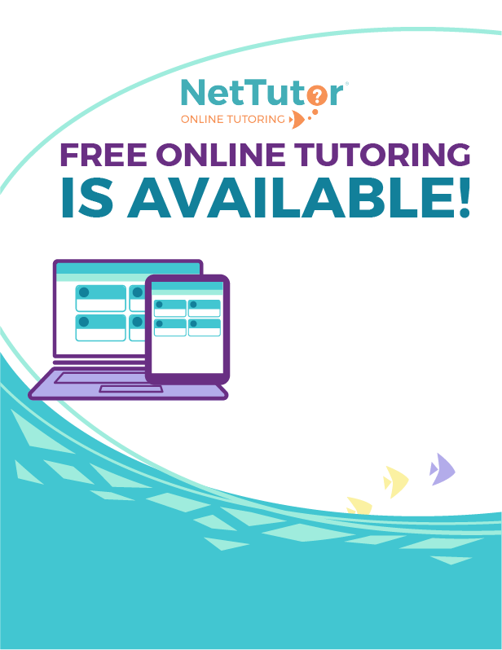
For more information, please contact:
Name
Number
Email
School Logo Here
Social Sciences
Languages
Humanities
Communication

Business
Economics
Health
Student Success

SUBJECTS
English
Reading
Writing
Mathematics
Sciences
Computer Science
Technology
FOR ACCESS TO
FREE ONLINE TUTORING
- Log into your account

- Click on the “Tutoring” tab

- Go down to the right-hand corner and click the link “Free Online Tutoring”

- Then click on the course in which you need a tutor and follow the prompts

