Custom NetTutor® User Guide Instructions

Student Hub Experience:

- Insert your institution logo on the next page (you may need to confirm permission with your institution’s PR team).
- As an option, you can replace the learning management system screenshot at the top of the next page with one that more closely matches your students’ access experience.
- Add a title to the file (usually under File > Info > Properties).
- Delete these pages:
  - #3 (NetTutor User Guide - Log in to your account at https://www.nettutor.com/)
  - #1 (Custom NetTutor® User Guide Instructions)
- Confirm the document is accessible (usually File > Info > Check for Issues > Check Accessibility)
- Save as a PDF file.

NetTutor Experience:

- Insert your institution logo on page #3 (you may need to confirm permission with your institution’s PR team).
- Add a title to the file (usually under File > Info > Properties).
- Delete these pages:
  - #12 (Select the Customer Care card from the student hub page to find helpful knowledge base articles and to open support tickets.)
  - #11 (Select the NetTutor Writing Center card from the student hub page to connect more directly to writing assistance.)
  - #2 (NetTutor User Guide - Locate the NetTutor link inside our school’s learning management system.)
  - #1 (Custom NetTutor® User Guide Instructions)
- Confirm the document is accessible (usually File > Info > Check for Issues > Check Accessibility)
- Save as a PDF file.

Institution Logo Here

NetTutor User Guide

Locate the NetTutor link inside our school’s learning management system.

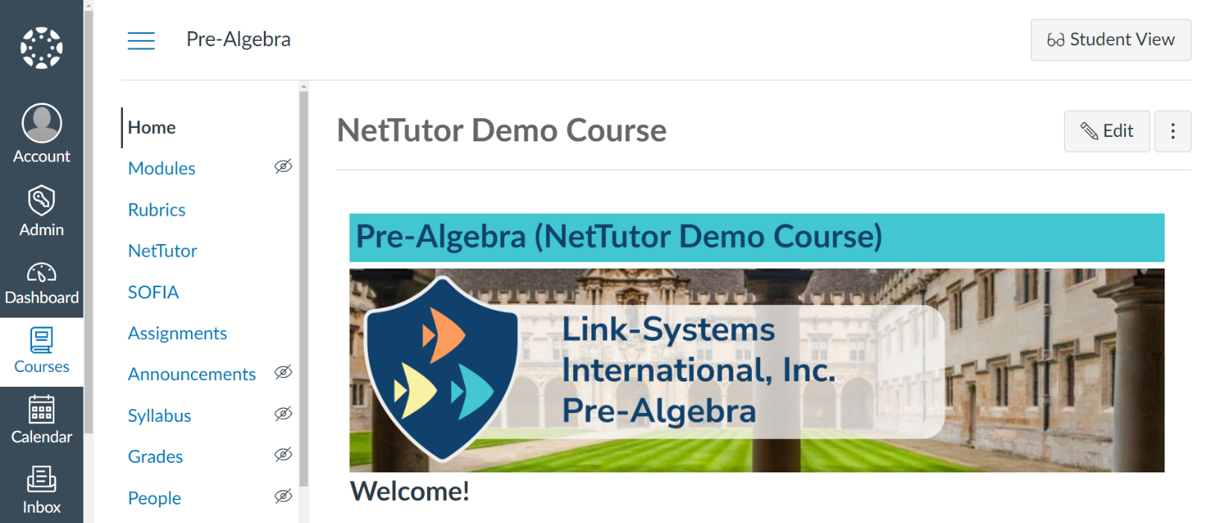

From the student hub page, click on the NetTutor Tutoring Center card to view all available tutoring groups.

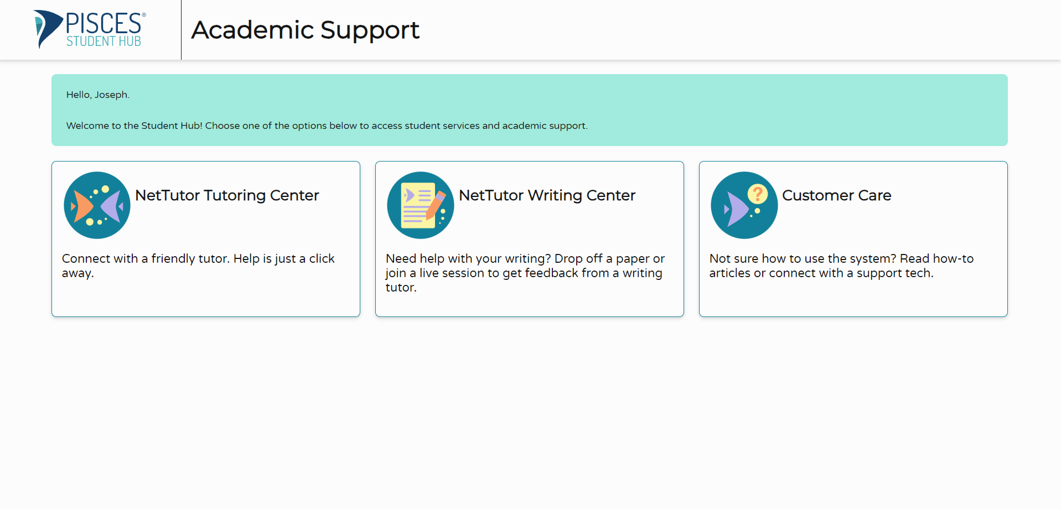

Institution Logo Here

NetTutor User Guide

Log in to your account at https://www.nettutor.com/.

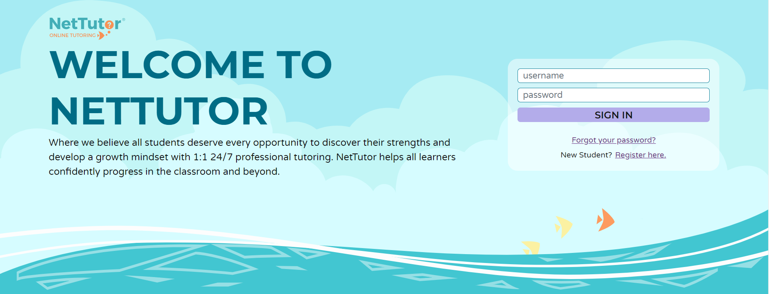

Upon first access from each device, you’ll be prompted to read and agree to NetTutor’s End User License Agreement.

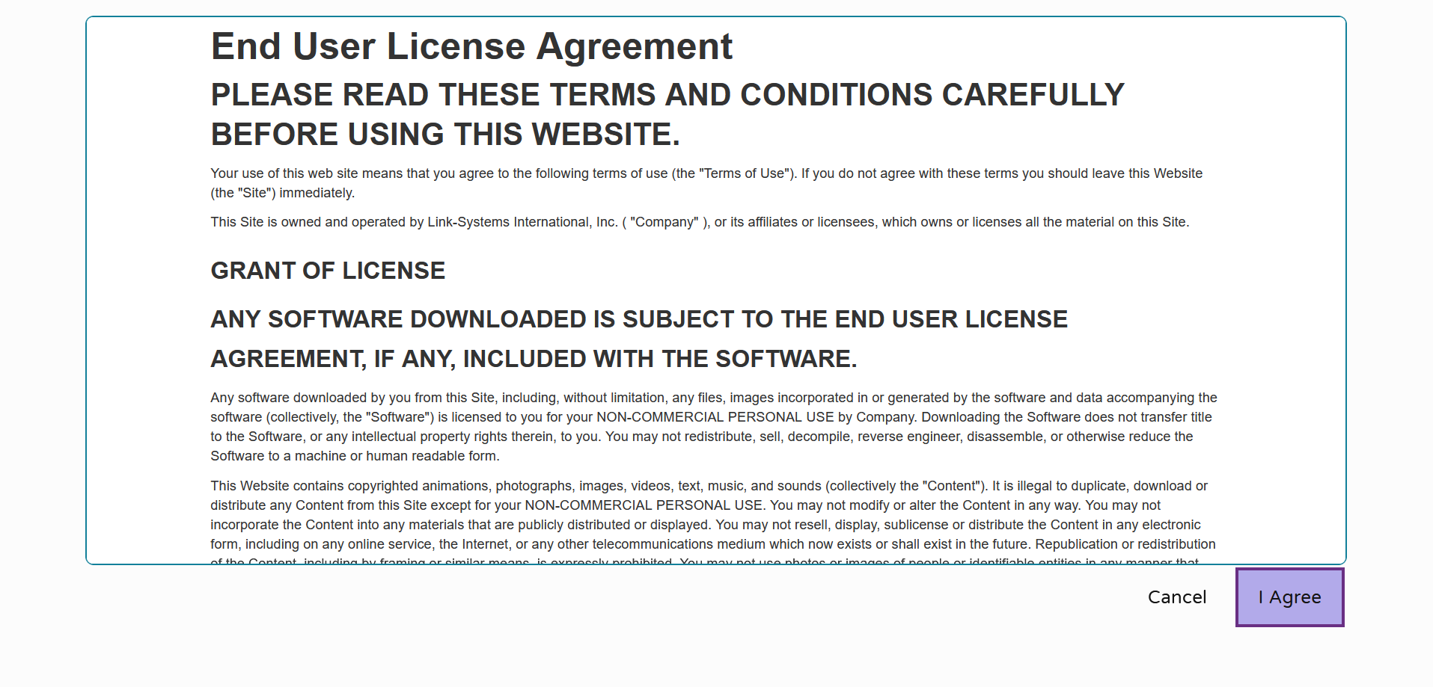

Select a group from the list to receive tutoring support in that area.

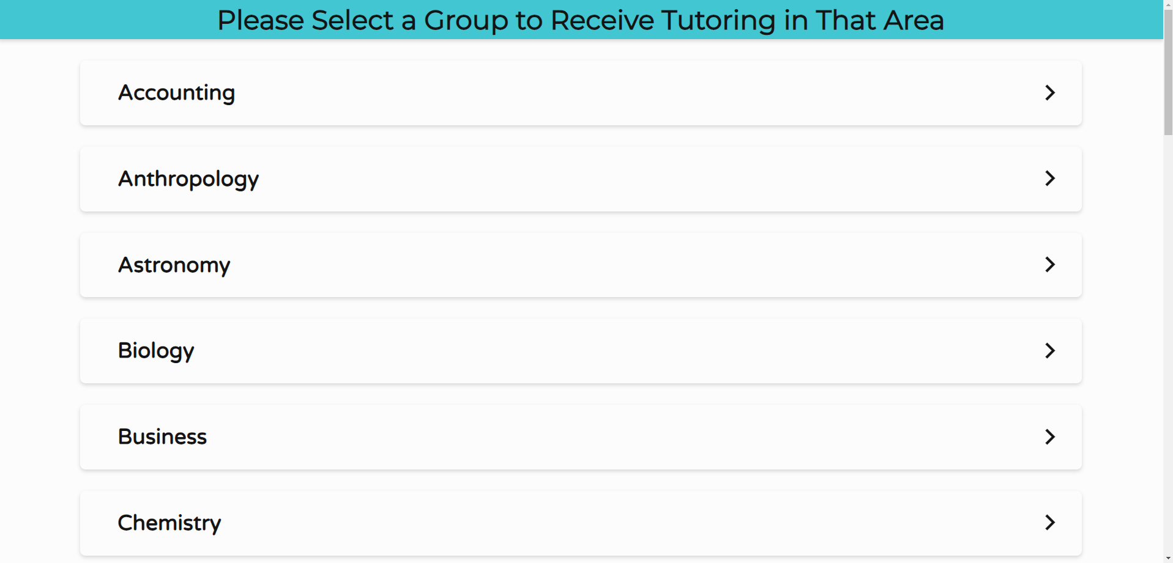

The NetTutor dashboard displays available tutoring resources along with the group’s locker.

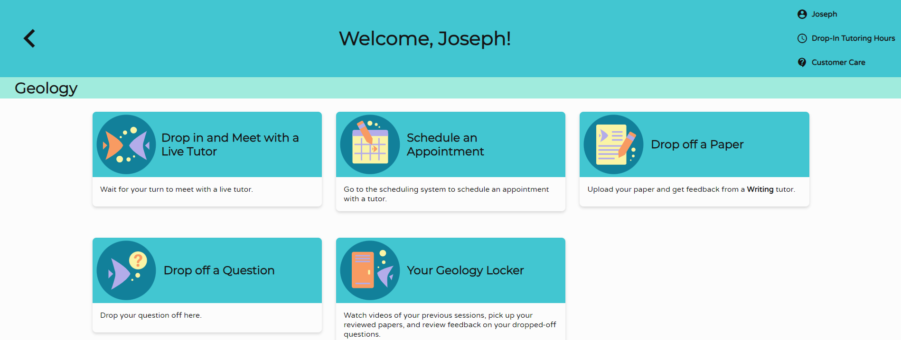

Drop in and Meet with a Live Tutor connects you with a tutor in NetTutor’s text-based lobby. Continue to work in the lobby, ask a tutor to open the whiteboard, or ask a tutor to launch video chat to use audio, video, and screenshare features.

Lobby view

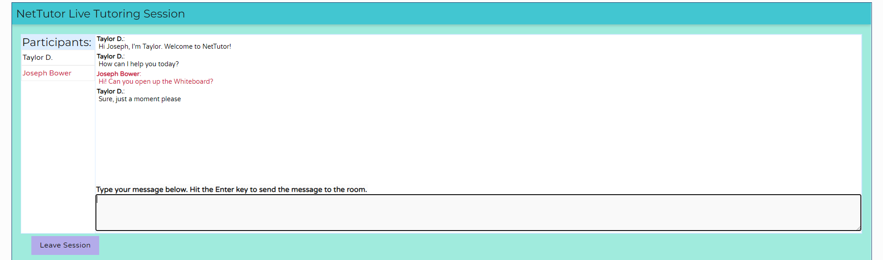

Whiteboard view

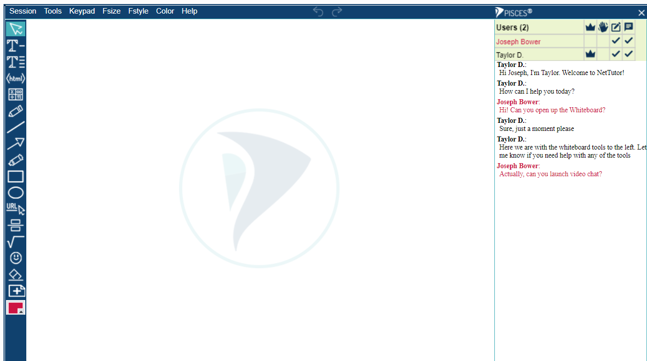

Video conference view

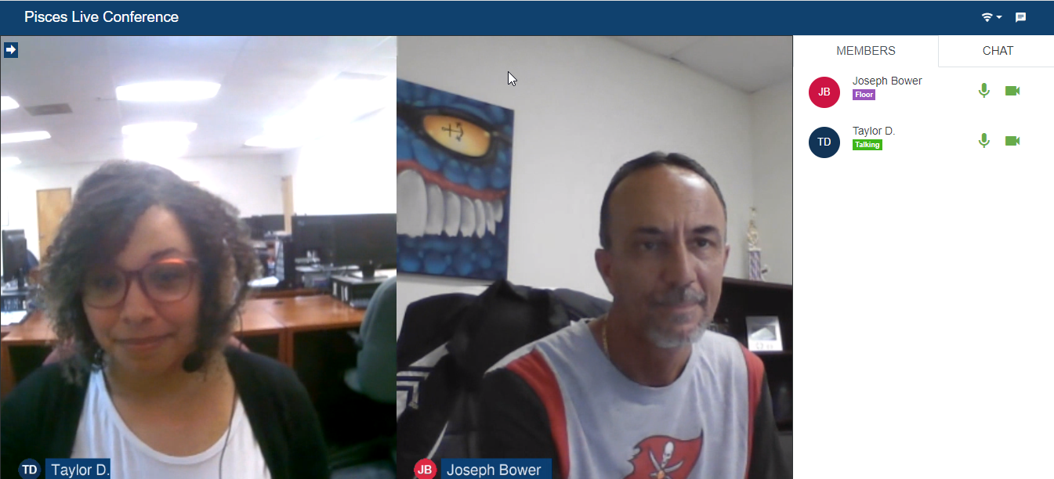

Schedule an Appointment directs you to the current list of available appointments from which you can select a convenient appointment and set notification reminders. Note: Availabilities are based on demand.

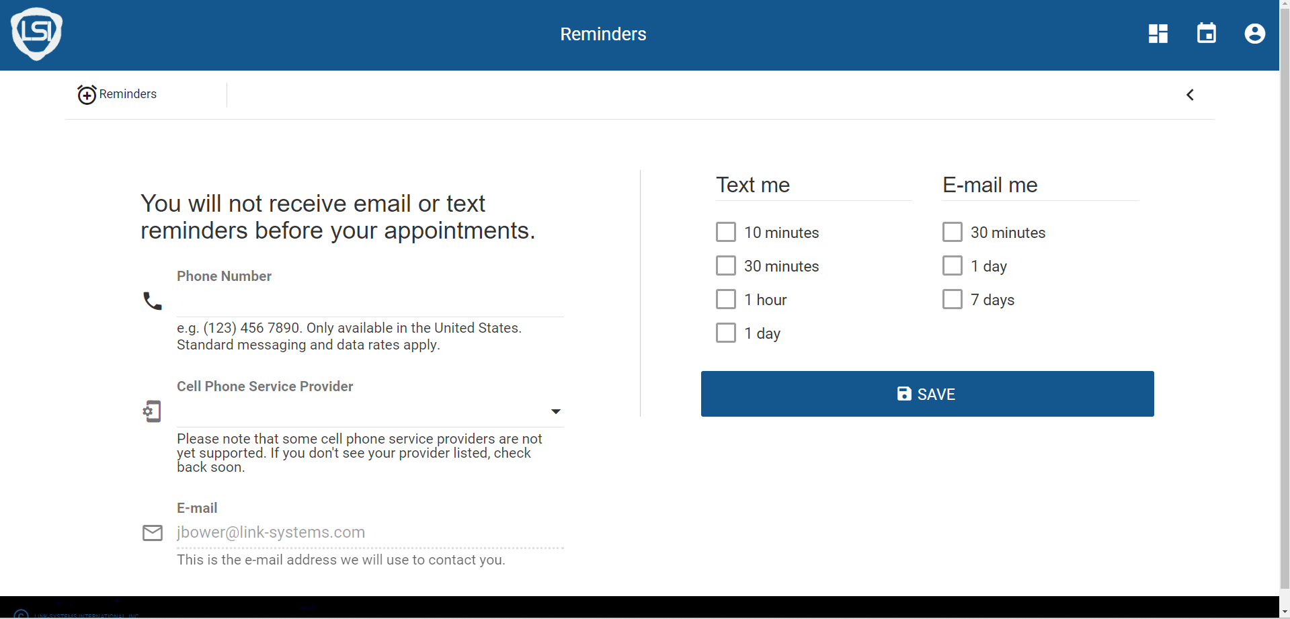

To join a scheduled session, arrive at the group dashboard shortly before the appointed time. The Join Session card will appear at the top of the group dashboard, and the Join Session button will activate when your tutor starts the session.

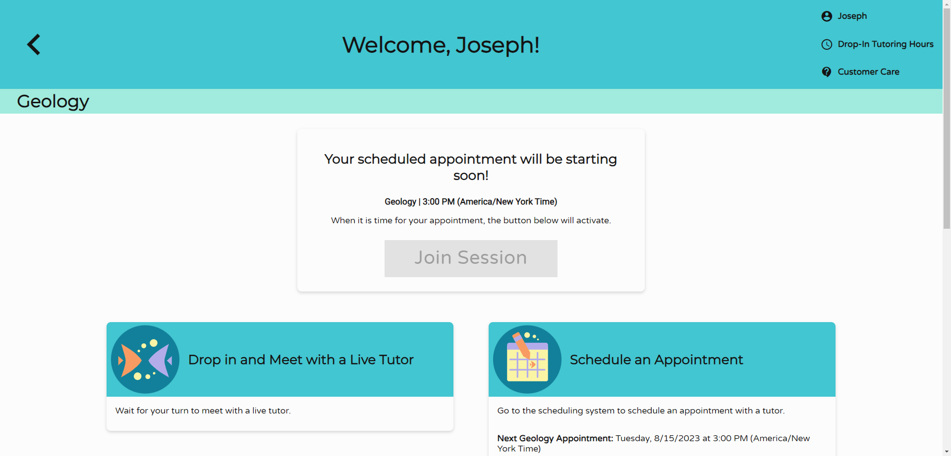

Drop off a Paper directs you to a simple 3-step process for submitting a paper for review.
Step 1: Provide basic information, including the name of the paper and a brief description.

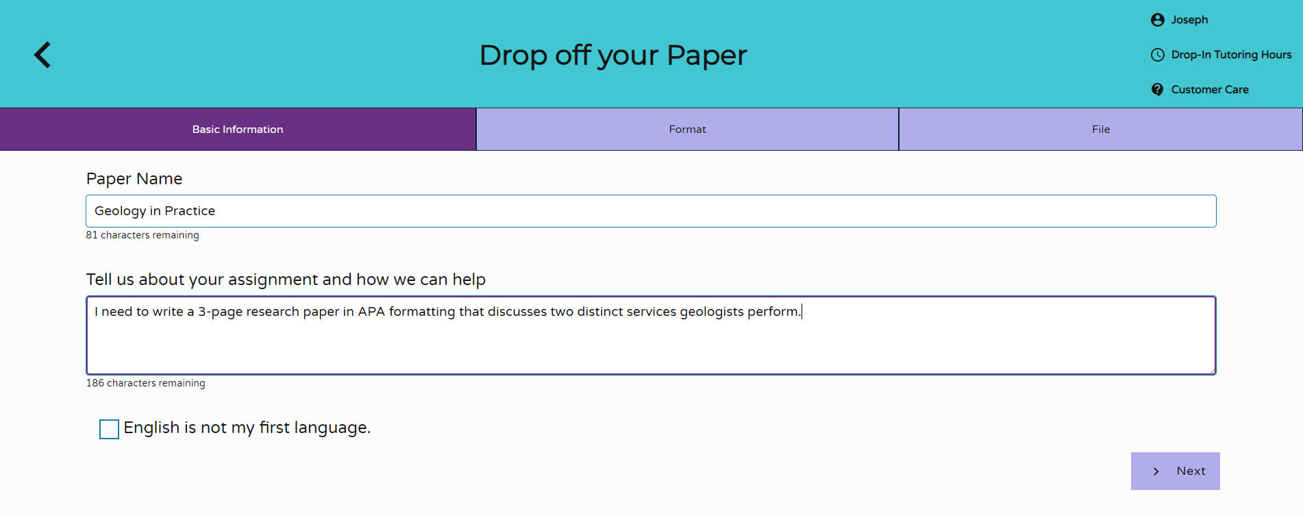

Step 2: Identify the help you need from a tutor.

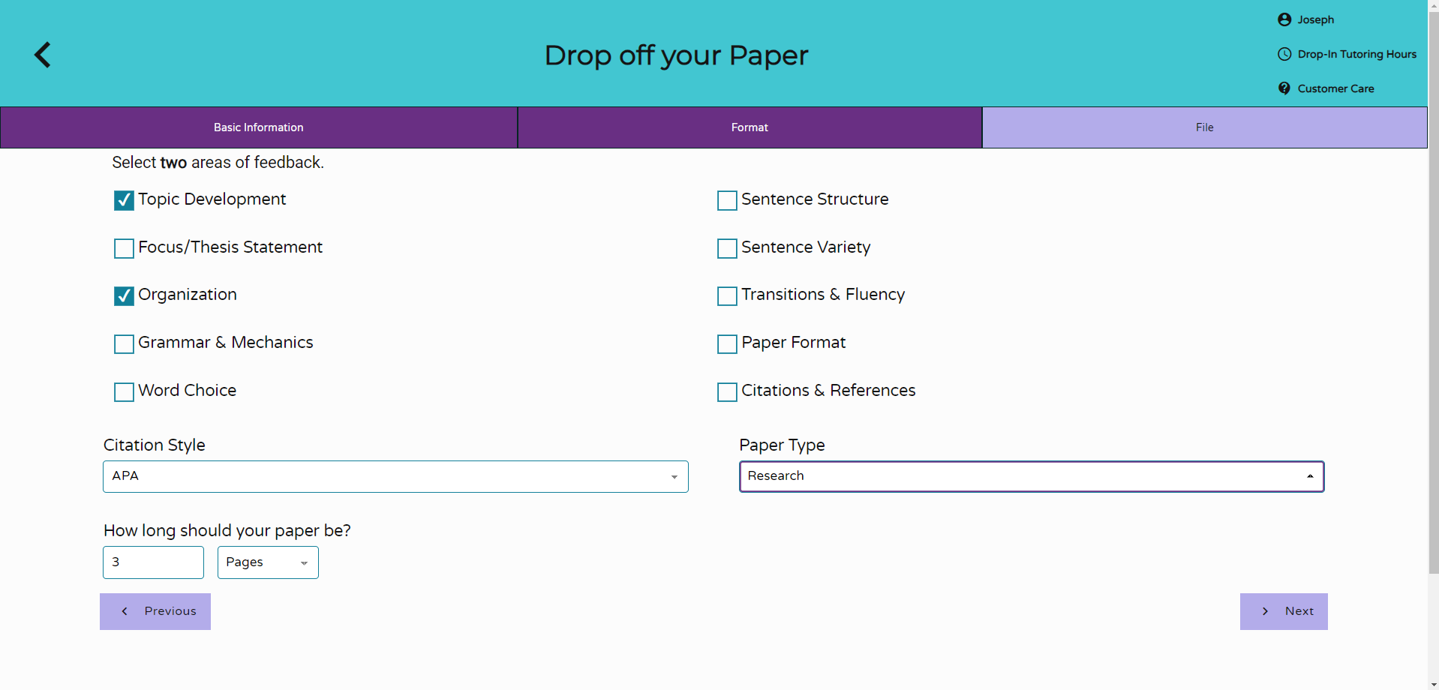

Step 3: Upload the paper. You can drag and drop the file or upload the file from your file directory.

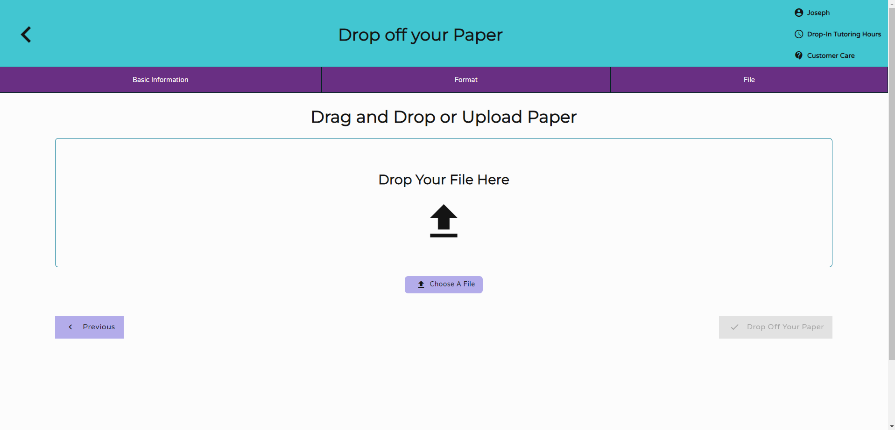

Drop off a Question allows you to show your work and drop off a question for tutor feedback in two steps.
Step 1: Give your question a title.

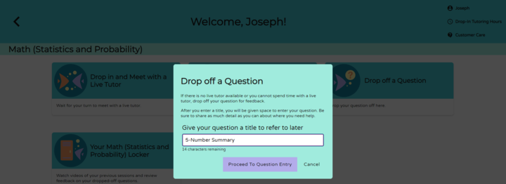

Step 2: Use the whiteboard tools to show your work and ask a question. Once you’re finished, click SUBMIT.

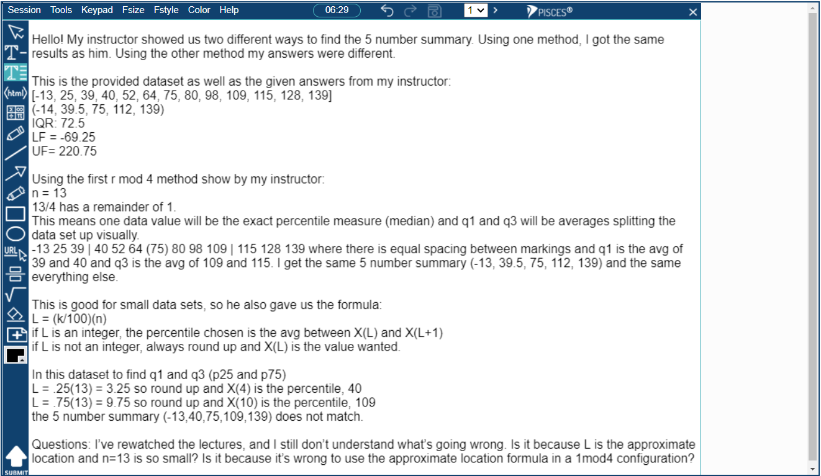

Your <<Group Name>> Locker stores all your NetTutor sessions. You can review your live and scheduled tutoring sessions, retrieve papers submitted for feedback, and gather responses to submitted questions all in one place.

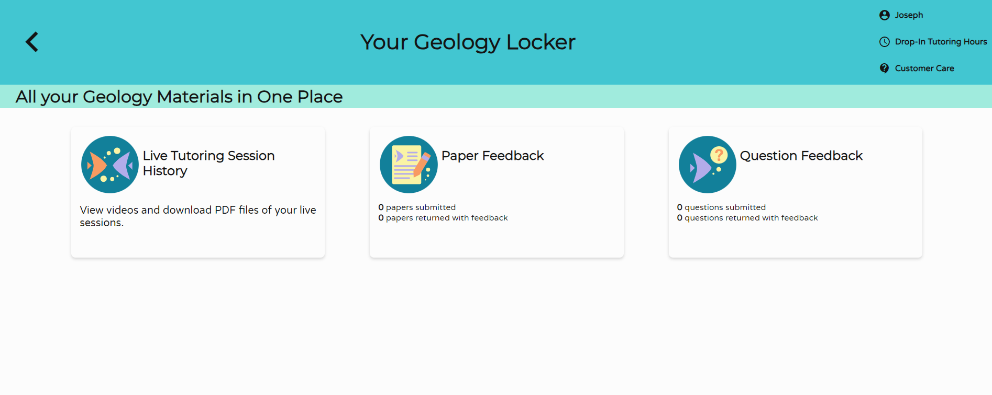

View profile details, drop-in tutoring schedule, and support resources at the top of any group page.

Select the NetTutor Writing Center card from the student hub page to connect more directly to writing assistance.

Choose from available tutoring resources in the Writing group or review tutor feedback in your Writing locker.

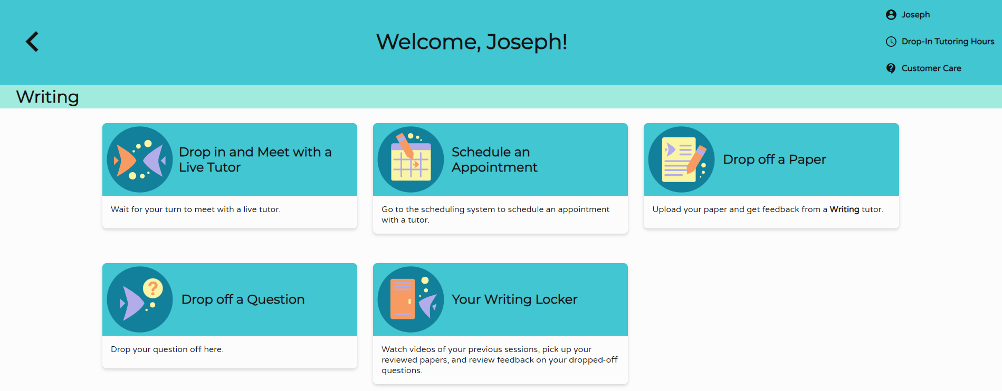

Select the Customer Care card from the student hub page to find helpful knowledge base articles and to open support tickets.

View answers to frequently asked questions, search for knowledge base articles, and open support tickets from the NetTutor Service help center.

